*Matthew Yiqing Zhu*

*For Westpac Interview*

*Design*

Project: Simple Weather Information Service

|  |  |  |  |
| --- | --- | --- | --- |
| Version | Author | Create/Update Date | Comments |
| 0.1 | matthew.yiqing.zhu | 2024 05 01 | Initialization |

1. Introduction:

This document is for the project’s code design.

1. High-level view:

* This project based on spring boot framework with a layered design.
* The controller layer work as web service endpoint to provide the service to client.
* Service Layer handle the business logic before providing the result to controller layer.
* The repository/DAO layer queries the data from the mocked database, and pre-process exceptional data (such as null data).
* Mocked In memory database creates recorded data then stores it in the memory handles the query from DAO and returns values.
* Other support classes like Pogo and Utils to support data when needed

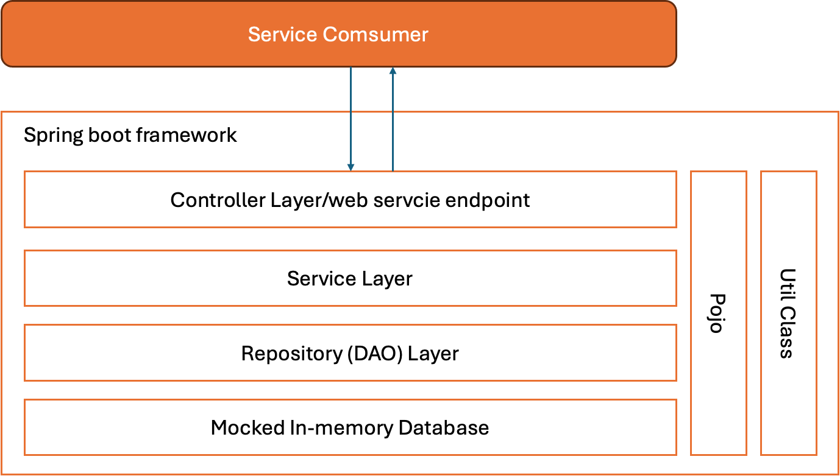

For the classed in each layer, please refer 1.2 ClassesList.xlsx